**Assignment(04-01-2024)**

**Name:**Aparna Kadiyala

**Email:**kadiyalaaparna2001@gmail.com

**Run your first ETL workload on Azure Databricks**

If we want to run our ETL workload on Azure Databricks,we need to follow some steps,Let me show what are all those steps.

[Step 1: Create a cluster](https://learn.microsoft.com/en-us/azure/databricks/getting-started/etl-quick-start#--step-1-create-a-cluster)

[Step 2: Create a Databricks notebook](https://learn.microsoft.com/en-us/azure/databricks/getting-started/etl-quick-start#--step-2-create-a-databricks-notebook)

[Step 3: Configure Auto Loader to ingest data to Delta Lake](https://learn.microsoft.com/en-us/azure/databricks/getting-started/etl-quick-start#--step-3-configure-auto-loader-to-ingest-data-to-delta-lake)

[Step 4: Process and interact with data](https://learn.microsoft.com/en-us/azure/databricks/getting-started/etl-quick-start#--step-4-process-and-interact-with-data)

[Step 5: Schedule a job](https://learn.microsoft.com/en-us/azure/databricks/getting-started/etl-quick-start#--step-5-schedule-a-job)

**Step -1: In this step,we need to create a cluster.**

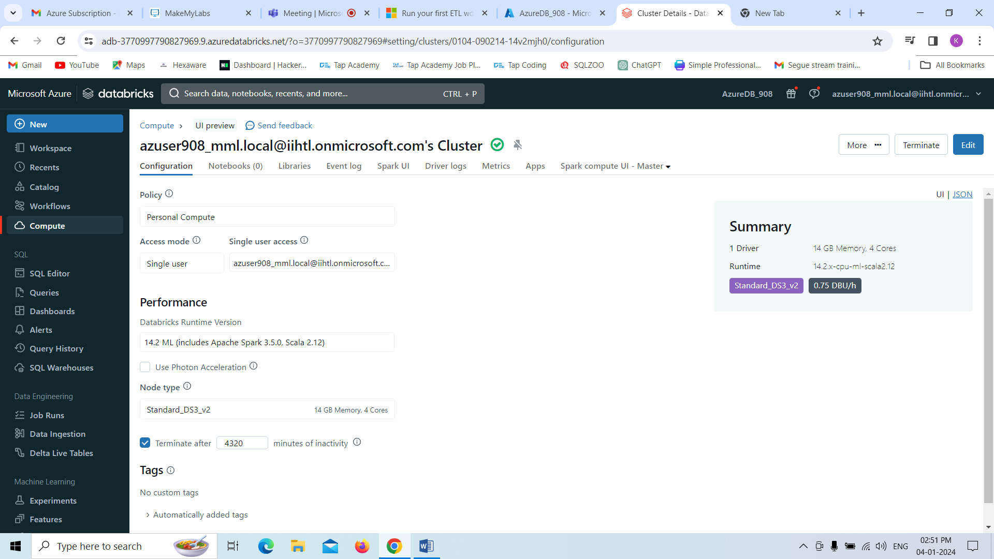

**Step-2**

After the cluster creation ,we need to create a notebook and that notebook must be attached with particular cluster we created.

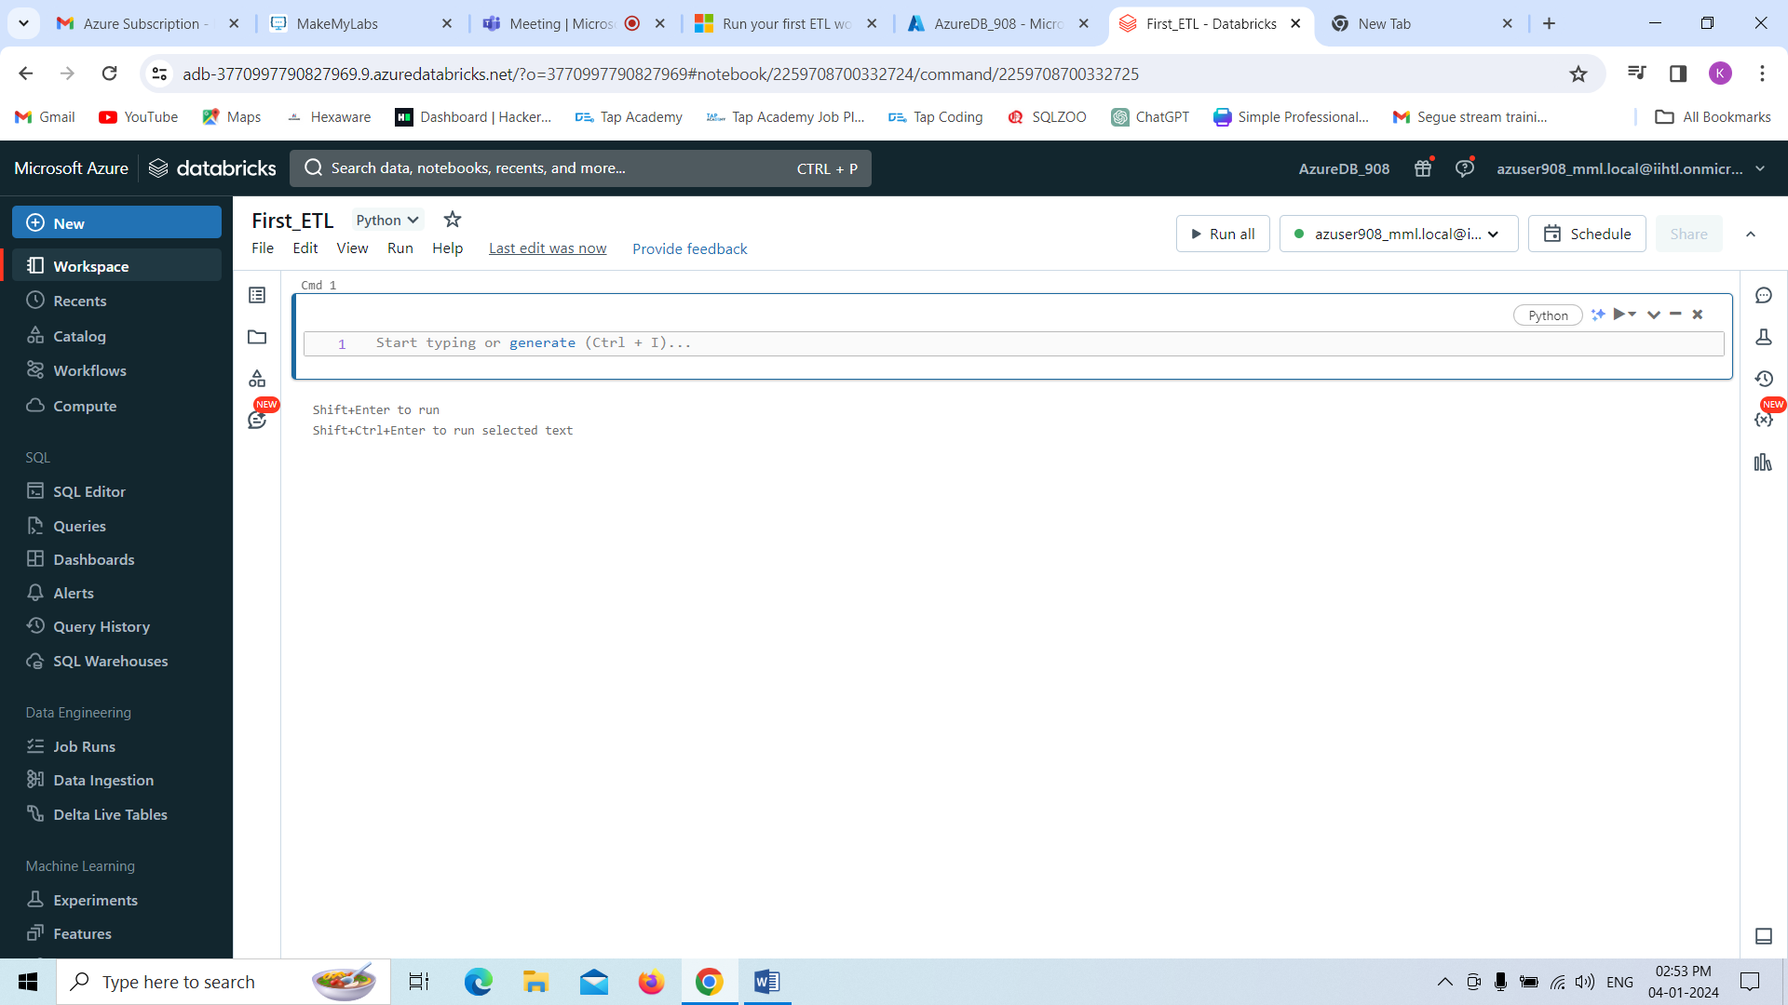

**Step-3**

Here we need to configure Auto Loader to ingest data to Delta Lake by default we have python API, if we want to perform in scala ,we can change to scala.

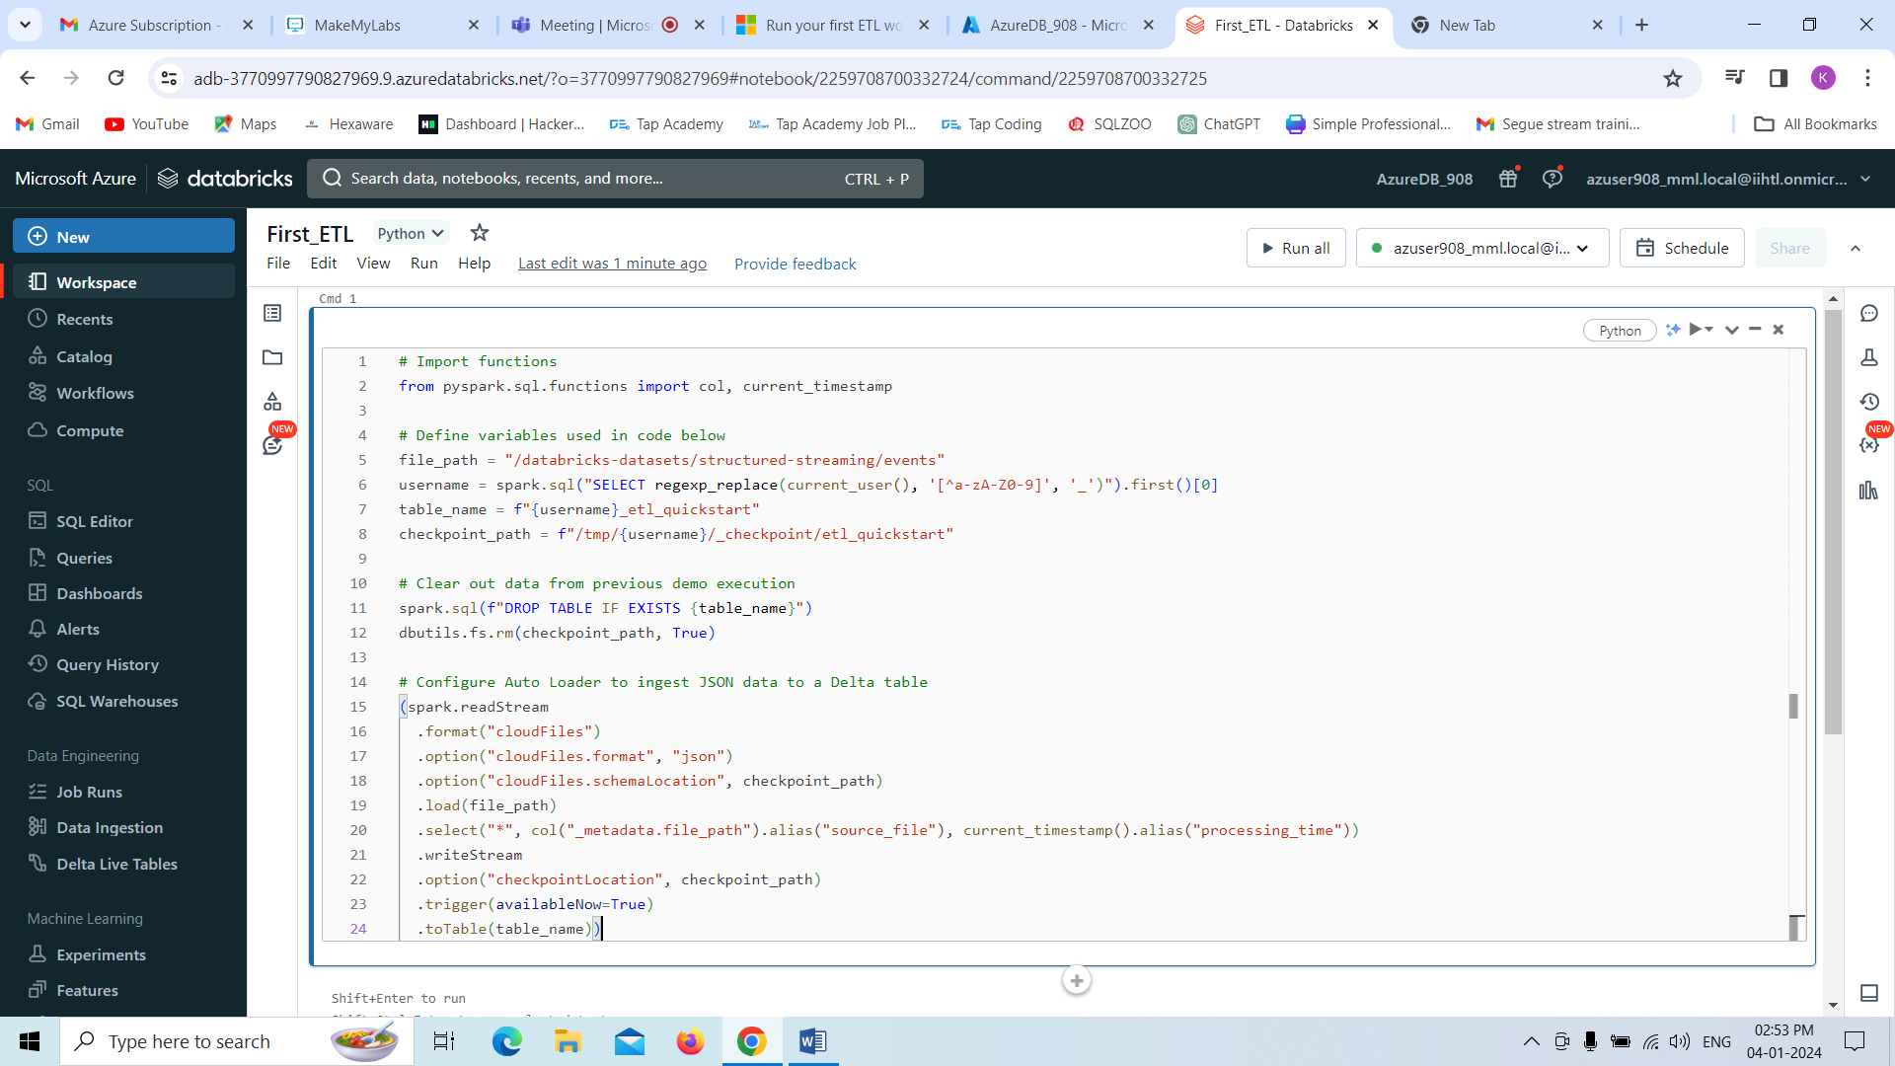

**Step-4:**

Here we are interacting with the data by running each cell in notebook.

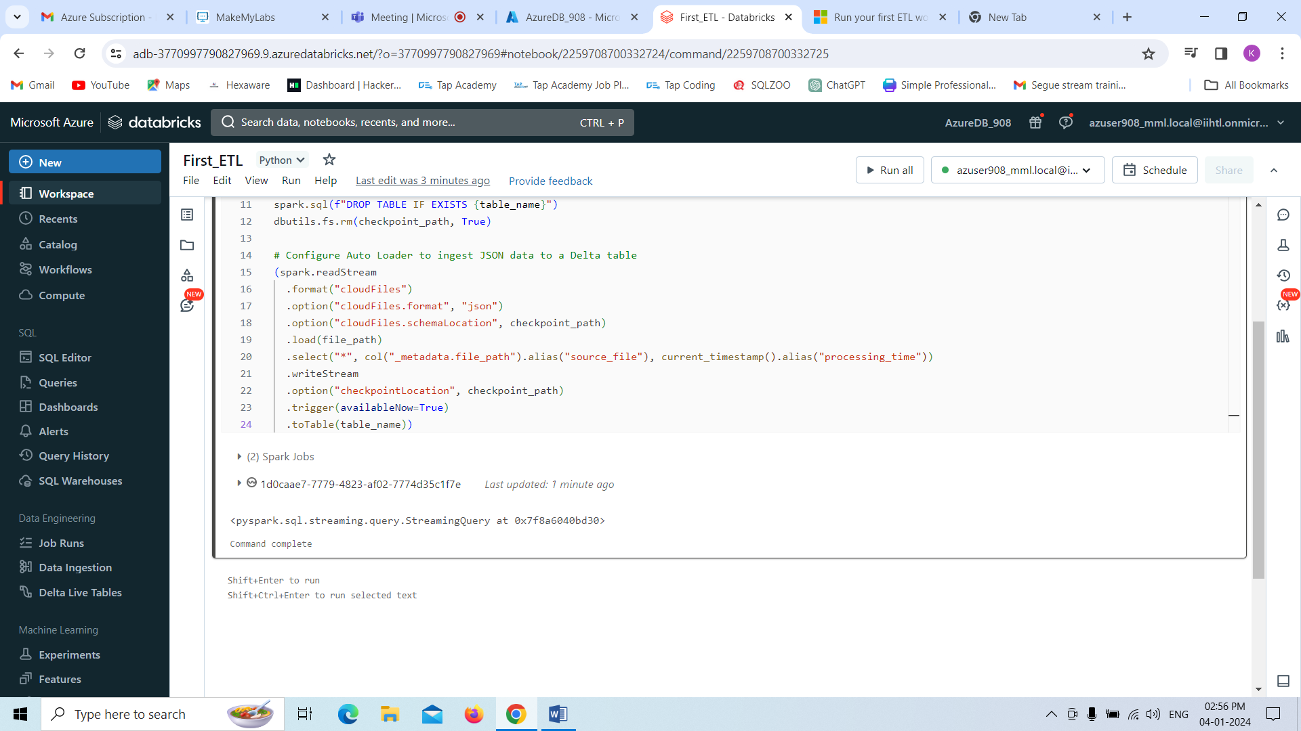

Here ,we are displaying the dataframe and all other details.

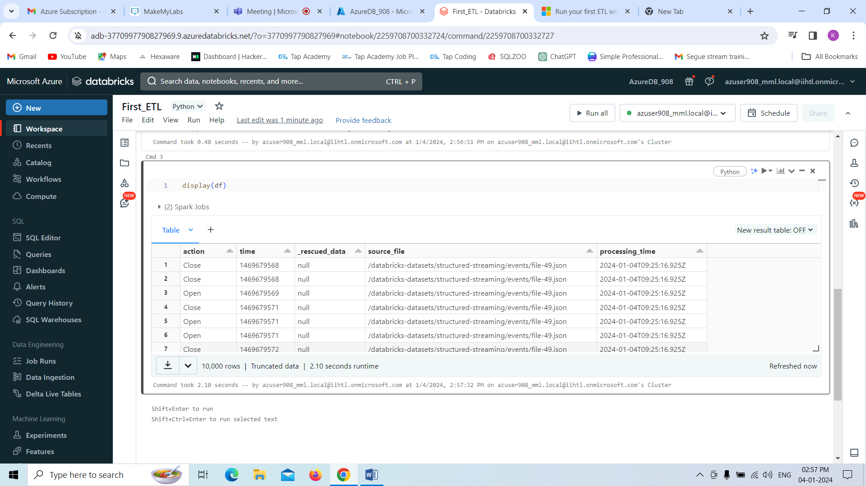

**Step-5**

Now we are Scheduling the job that is manually we are doing over here.

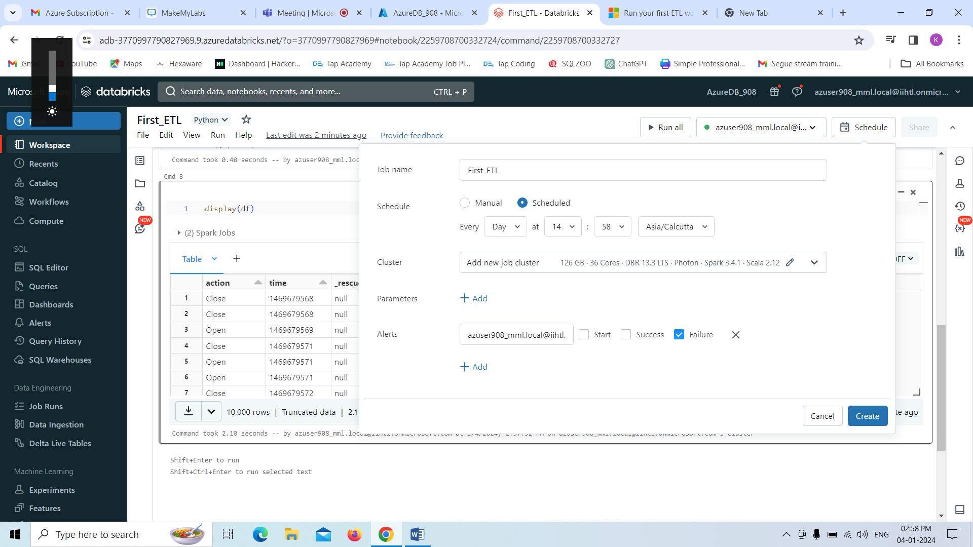

Here we are attaching to the cluster what we have been created before or as we like we can attach and click on **create.**

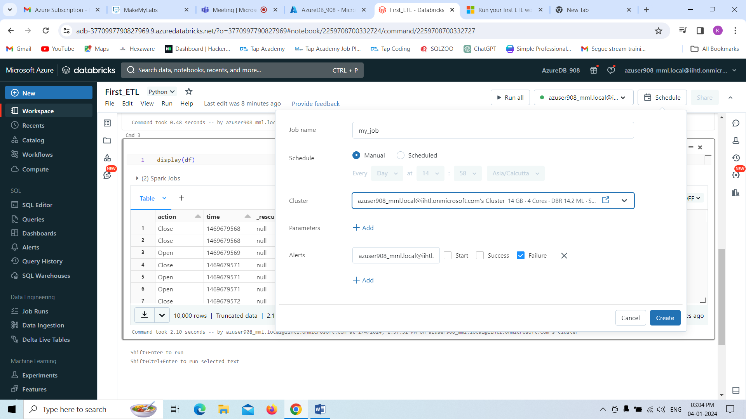

Below you can see the message that job has been created successfully.

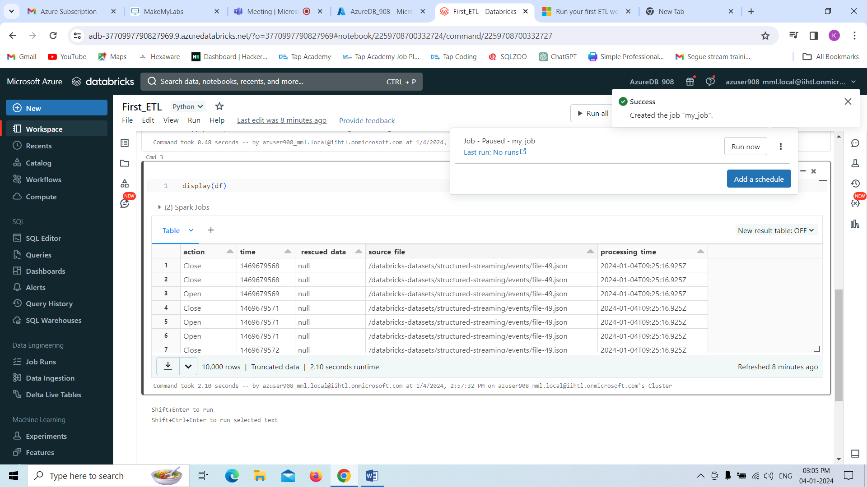

Finally,if we want to see the running job click on **Run now** we can see .

